GET239 Lecture Notes
Data in the Computer Week 2

How does a computer application access data?
To move data and/or computer programs (application logic) in a distributed computing environment an application program has to request file access to the physical storage media by using the operating system’s “access methods.” All requests for input or output (I/O) are made as requests using interrupts to and from the operating system’s File Management and I/O Services facilities performed in conjunction with the physical device’s I/O control unit.

Data is normally stored to what is referred to as “permanent” or secondary storage devices. The facilities at the file management level are called “access methods.” At the I/O Services level these access methods consist of small programs called device drivers. Since the majority of a system’s data is stored on direct access storage devices, i.e. disk drives, the data has to be stored in physical blocks. The device drivers working with the disk’s I/O control unit make the physical data bock transfer to/from the actual device, and then signal the operating system, via an interrupt, when the transfer is complete. See figure 1 below:
The application requests an I/O interrupt from operating system’s file management and I/O services facilities

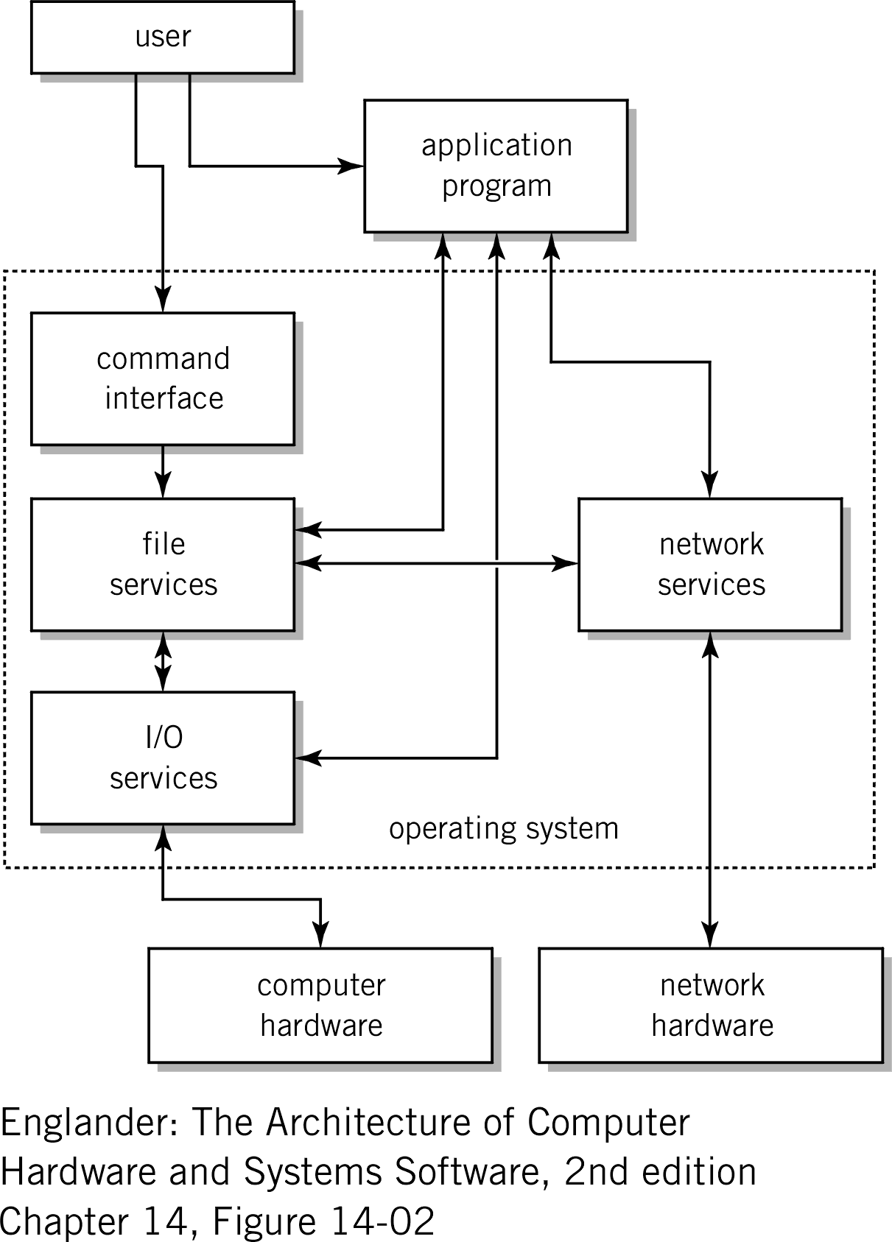

Application

Access
Methods

Device
Drivers

Disk
Drives

Figure 1 - I/O Architecture

How does data physically get to the surface of the disk?

Physical Data Storage
On the physical disk “platter” the data is stored as physical data blocks. Data blocks can be a series of logical records where each record is made up of one or more fields which in turn is made up of one or more characters. These data blocks, sometimes referred to as physical records, can be stored in fixed or variable lengths. The database designer selects the appropriate data type and length for each field. The I/O device drivers (software) are responsible for establishing the data transfer to the appropriate device and the I/O control unit (hardware) is responsible for performing the actual recording to or reading from the specific device media. See figures 2 and 3 below:

Read/Write
Mechanism … mechanical arm positioned over the media surface

Device address:
Cylinder, track, sector
To I/O Module
10011101001100…

Block

Device media or “platter” can rotate at speeds in excess of 15,000 rpm

Figure 2 - Logical Device

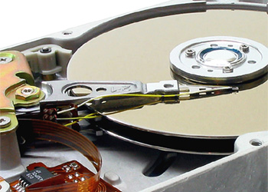
Here is a better view of the surface of the disk where the data is recorded.

Notice the read/write head mechanism. The movement of the head is the slowest part of data access.

Figure 3 – Physical Device
How does natural language data actually get recorded?

But before natural language data can be written to the disk or memory it needs to be put in a format that the computer understands.
As we learned above data blocks are actually stored on the surface of the disk as a string of pulses, where each pulse is in either one of two states, positive or negative polarity. Since there are only two states we refer to this as binary. The direction of the polarity (i.e. + or -) determines if the data is interpreted as a binary one or a binary zero.

So how do we tell the computer to store the letter “A”, specially a capital A? Well, in order to represent a character other than a one or zero, computer designers came up with various coding schemes consisting of a string of ones and zeros to represent many of the common characters needed by computer users. There are three very popular coding schemes in use today: ASCII, EBCDIC and Unicode. These coding schemes made it practical for us to store and process natural language characters on “two-state” or binary computing devices. Let’s take a look at how the character “A” is encoded in ASCII.

Below is an ASCII conversion table of the first 128 characters that we’ll use to convert our “A” into a binary string of ones and zeros, suitable for data storage on a disk’s surface.

Capital “A” is a Hx 41

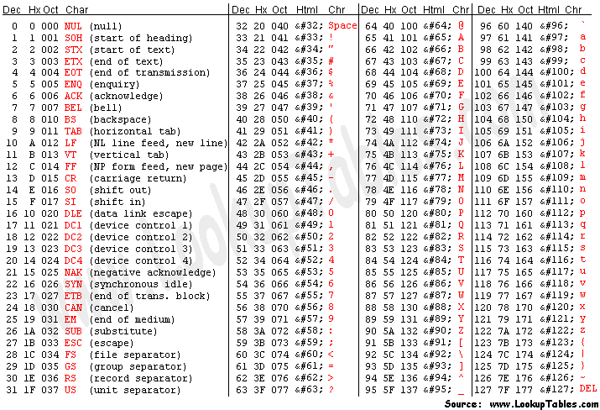
Figure 4 – ASCII Conversion Table
Using the above ASCII conversion chart we see that a capital “A” is a hexadecimal 41. If we covert this hexadecimal number to its 8-bit binary representation we get “01000001”. We use hexadecimal as a “shorthand” method so that we don’t have to remember or write down the binary values; since binary numbers can get quite long and tedious to work with. The hex 4 is 0100 in binary and the hex 1 is 0001 in binary. So the disk surface will have the polarity changed to record the following string of 8 bits: 01000001. Let’s look at this again. This time let’s also convert a lowercase “a” as well:

Natural: A a

Hex: 41 61

Binary: 0100 0001 0110 0001
With this method for converting natural language characters to binary you can represent any character to a binary equivalent and make it easy store on digital media.

Let’s try another Example
Let’s take the name “Dave D” to see how it is stored on the disk:
Natural: D a v e D
Hex: 44 61 76 65 20 44
Binary: 0100 0100 0110 0001 0111 0110 0110 0101 0010 0000 0100 0100
This is what “Dave D” looks like written to disk or stored in main memory

Now you try one
See if you can decode the following ASCII message:
57 65 6C 65 63 6F 6D 65 20 74 6F 20 49 53 54 36 35 39
What did this message say? Is it spelled correctly?
What are the most Common Coding Schemes?
Here are the three most common computer coding schemes. All three of them are still in use today. Can you think of any issues with trying to distribute data in a distributed computing environment going from one coding scheme to another?
ASCII - The American Standard Code for Information Interchange started out as a standard seven-bit code that was proposed by ANSI in 1963 and finalized in 1968. Much of the work on ASCII has been credited to Robert W. Bemer. ASCII was established to achieve compatibility between various types of data processing equipment. Later-day standards that document ASCII include ISO-14962-1997 and ANSI-X3.4-1986(R1997).
ASCII, pronounced "ask-key", is the common code for small computing platforms. The initial ASCII character set consisted of 128 characters that include decimal numbers, letters, numbers, punctuation marks, and the most common special characters. The Extended ASCII character set consists of the original 128 characters plus an additional set of characters making it a 256 character coding scheme.
EBCDIC - Extended Binary Coded Decimal Interchange Code was a further development of older codes like BCDIC, BCD dating back to work done by Herman Hollerith. EBCDIC was designed as an 8-bit code, because the new System 360 used a 32-bit machine word. With 8 bits EBCDIC supports 256 characters. It is used primarily in the large computer environment, specifically mainframes and some mid-frame computing platforms.
EBCDIC, pronounced “ebb-c-dick”, was deployed in the early 1960s by IBM when they announced a new computer series that became known as System 360. It turned out that EBCDIC followed a direction totally different from ASCII, where the heritage of paper tape was clearly established. So EBCDIC and ASCII are not compatible and require a translation to move data from an EBCDIC machine to an ASCII machine.
Unicode – Universal Code has a 16-bit coding scheme that compensates for the short-comings of 7 and 8 bit coding schemes. ASCII and EBCDIC worked fine for English and the Romance languages but didn’t have enough character combinations to support the alphabets of languages from Eastern Europe, Asia and Africa. With 16 bits Unicode can support over 65,000 characters. The first 256 Unicode characters are the same as ASCII.

Summary
Distributed computing can only exist because of this capability to move data (or programs) from disk can so that they be moved or copied to another computer in a distributed computing environment and stored there, locally. It is this movement of data from disk-to-memory, memory-to-disk or computer-to-computer across the network that makes distributed computing a reality.

